SDC04 2020 – 21

Part 1A STRUCTURAL DESIGN COURSE

DESIGN HANDOUT

Groups: 46 – 60

Problem: 1S (Steel Cantilever)

Demonstrator: Dr James Talbot (jpt1000)

Assistant: Dr Miguel Bravo–Haro (mab261)

Timetable
Structures Research Lab  Structures Research Lab  Structures Research Lab  Structures Research Lab | Mon 9 Nov (Week 5)  Mon 16 Nov (Week 6)  Mon 23 Nov (Week 7)  Mon 30 Nov (Week 8) | 9 – 11 am  9 – 11 am  9 – 11 am  9 – 11 am
Workshop | Thu 21 Jan – Wed 25 Jan  (Week 1, Lent) | 1 pm – 3.10 pm (46 – 52)  3.20 pm – 5.30 pm (53 – 60)
Test: SRL | Tue 2 Feb (Week 2, Lent) | 11 – 1 pm
Feedback Session⁺ | Mon 15 Feb (Week 4, Lent) | 9 am – 11 am
⁺Each group will be allocated a 15 min slot during this session via Teams.

DEADLINES
Drawings*  Structure, Drawings & Costing Sheet†  Report* | Wed 2 Dec (Week 8)  Wed 25 Jan (Week 1, Lent)  Thu 4 Feb (Week 3, Lent) | 5 pm  5.30 pm  1 pm

* Drawings and Report to be photographed and submitted to Moodle at
1CW: Structural Design, in the respective sub-folder (labelled by lab-groups).

† All items to be handed into the Structural Design Course Cost Centre located in the hallway outside the Structures Teaching Laboratory: these will be collected by the Course Technician. Costing must be performed PRIOR to submission of the finished structure, and the Costing Sheet photographed for inclusion in the Report.

FIRST YEAR STRUCTURAL DESIGN PROJECT: NOTES FOR STUDENTS

- Students work in their lab-groups to design, build and test to destruction a light-weight truss with a span of about one metre.

- Each student is also issued with a laboratory notebook. All calculations and sketches are recorded in this notebook.

- Each lab-group produces a set of working drawings for their structure using pencil and paper. High resolution, careful photographs of these drawings are submitted to Moodle by the required deadline. Each student must submit the drawings they have been responsible for, clearly indicating their name and lab-group number in the filename. Each lab-group must then bring their physical drawings at the start of the first fabrication session, which will be displayed until their structure is built.

- All students fabricate their structures in the Dyson Centre Workshop, under the supervision of a senior technician and other technical staff. There are five programmed afternoons available: the times of working must be observed; no fabrication is allowed outside these times. Safe working practices must be observed at all times, including social distancing: safety glasses, sensible shoes and clothing to be worn; no loose clothing, and long hair tied back. The amount of scrap material produced during fabrication should be minimised through careful planning and execution.

- The coursework takes precedence over all other activities. If a timetable clash should arise, students are requested to inform the Course Coordinator and/or their Director of Studies as appropriate.

- The final structure must be costed before it is handed in, using the costing sheet (which should be detached from the end of this handout). The total cost is based on the weight of the completed structure and the number of fasteners used. If the amount of scrap material generated is deemed to be excessive, the scrap material will be weighed and added to the cost of the structure.

- The completed structure, the physical drawings and the completed costing sheet are submitted in person to the Structural Design Course Cost Centre located in the hallway outside the Structures Teaching Laboratory. Students are advised to take any photographs of their completed structure before they leave the area (as they will not be able to return before testing); the costing sheet must also be photographed for their report. All items will be quarantined before testing.

- Each structure is tested to destruction in descending order of cost, following an oral presentation by each student in the lab-group.

- Students individually write a concise report in the unfilled, opposite end of the laboratory notebook. Word-processed reports are acceptable provided each page is glued into the notebook: word-processed calculations are not permitted but must be hand-written. The following detail is required in the final report:

(1) summary; (2) statement of the problem; (3) summary of the design process with neat sketches of considered designs; (4) a complete set of hand calculations for the final design; (5) completed costing sheet (returned at the testing session); (6) list of deviations of the structure as built from that drawn; (7) test results and observations; (8) suggested modifications to improve performance; (9) conclusions.

The total length of the report cannot exceed ten notebook pages altogether. The final report is then photographed page-by-page and assembled into a single electronic document for submitting to Moodle by the required deadline. The document should be legible i.e. of good resolution, with all pages properly oriented, ordered and filling the available space, and clearly labelled with the owner’s name and lab-group number (as per the submitted files for drawings).

- The total number of marks available for the course is 42, divided as follows: completion of drawings, 12; construction and test, 12; oral presentation and report, 18.

- Minimally acceptable work attracts 28 marks (negative credit limit); satisfactory work, 35 marks; exceptional work, 42 marks. In addition to the quality of the report, the contribution to the design, drawing and fabrication of the structure by each student is assessed. The design concept, the accuracy of the calculations, and the performance of the structure are also considered: a failure to meet the loading requirements might only result in a slight reduction in marks.

- Marks are deducted for any failure to meet deadlines, or any unauthorised lateness or absence:

failure to meet any of the deadlines – 1 mark;

failure to attend any one of the design or fabrication periods – 2 marks;

failure to attend the test or feedback session – 6 marks;

failure to submit a report – 12 marks.

- A prize is available for the best structure in each cohort. This will normally be awarded to the lowest cost structure that carries the collapse load to within 5% of its value. However, the final decision rests with the demonstrator, who may choose to also consider factors such as design elegance, originality and build quality.

- A feedback session will take place on Teams, where students will receive their overall mark for the project.

PROBLEM 1S

A structure is required to carry a vertical load W at a horizontal distance of 815 mm from a rigid vertical plate as shown. The plate has four pairs of M6 tapped holes to which the structure may be attached. The load is applied to the structure through a spreader bar length of 115 mm, thus dividing the applied load into two loads, W/2.

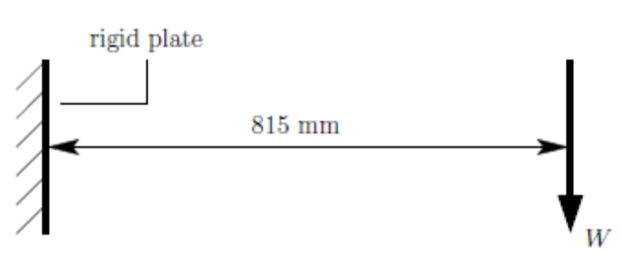

The working loads are: W = +1350 N and W = -135 N; at both these loads, there must be no visible deformation. The load factor at collapse equals 2, and is applicable to both positive and negative values of W.

It is essential to confirm the loading arrangements before detailed drawings are made; the designers are responsible for making any required measurements.

The objective is to design a structure with the given material that will satisfy the loading conditions; importantly, the structure must be lightweight and simply made.
MATERIAL DATA FOR MILD STEEL

ANGLES |  |  |  |  | SHEET
size  [mm] | thickness  [mm] | area  [mm²] | mass/length  [g/m] |  | thickness  [mm] | mass/area  [kg/m²]
9.5 x 9.5 | 0.7 | 13.3 | 104 |  | 0.7 | 5.49
12.5 x 12.5 | 0.7 | 17.5 | 137 |  | 0.9 | 7.06
12.5 x 12.5 | 0.9 | 22.5 | 176 |  | 1.1 | 8.62
16.0 x 16.0 | 0.9 | 28.8 | 226 |  | 1.4 | 10.98
16.0 x 16.0 | 1.1 | 35.2 | 276
19.0 x 19.0 | 1.1 | 41.8 | 328

size | major diameter [mm] | core area [mm²] | failure load [kN] |  |  | critical load in bearing  of sheet thickness [kN]
size | major diameter [mm] | core area [mm²] | single shear | double shear | tension | 0.7 mm | 0.9 mm | 1.1 mm | 1.4 mm
STEEL POP-RIVETS ^{[1]}
- | 3.20 | - | 1.26 | 2.52 | - | 1.37 | 1.76 | 2.16 | 2.75
CHEESE-HEAD STEEL NUTS AND BOLTS
M6 | 6.00 | 17.9 | 4.49 | 8.98 | 7.78 | 1.93 | 2.48 | 3.05 | 3.85
M5 | 5.00 | 12.7 | 3.16 | 6.32 | 5.48 | 1.62 | 2.07 | 2.52 | 3.22
M4 | 4.00 | 7.7 | 1.96 | 3.92 | 3.40 | 1.30 | 1.66 | 2.02 | 2.58

Three lengths of rivet are available, offering three different ranges of grip length:
‘short’, 1.4 – 3.0 mm; ‘medium’, 3.0 – 5.0 mm; and ‘long’, 5.0 – 7.0 mm.

- H A Evans, Rivet Testing for the Structural Design Course, CUED UROP report, 2016
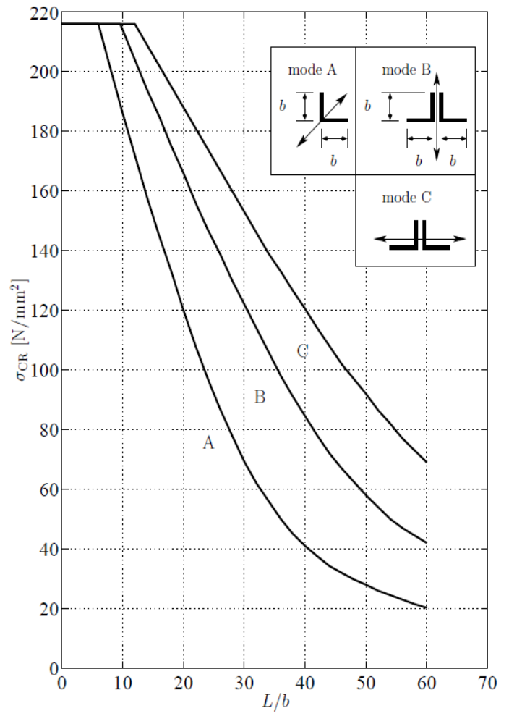
BUCKLING OF MILD STEEL ANGLE STRUTS

1A STRUCTURAL DESIGN COURSE COSTING SHEET

DESIGNED | Name
DESIGNED | Lab Group
CHECKED

This sheet must be completed immediately after fabrication and submitted with the completed structure to the course technician for checking.

MATERIALS |  | NUMBER | UNIT COST / ITEM | TOTAL
mass of structure [kg] |  |  | x 60 for steel  x 500 for aluminium
pop rivets |  |  | 0.1
bolts | M6 |  | 3.0
bolts | M5 |  | 2.5
bolts | M4 |  | 2.0
TOTAL COST

